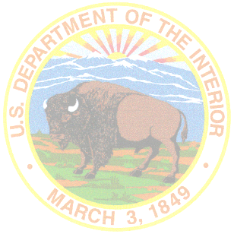***Tribal/Interior Budget Council***

***Budget Subcommittee Meeting***

***Agenda***

**March 11, 2025**

**9:00 a.m. - 12:00 p.m.**

**Tribal Subcommittee Co-Chairs:**

W. Ron Allen, Jamestown S'Klallam Tribe

**Federal Subcommittee Co-Chair:**

David Mahooty, Director OBPM

* Welcome and Opening Remarks
* Voting Member Roll Call
* IA Budget Update
  + FY25 Budget Update
  + Funding Status Update (Impacted programs)
  + Staffing Updates (FY24, current, projected)
* FY 2026 Budget Request Update
* Summary of Action Items for Report Out
* Adjourn